Subject: Follow-Up on Misrepresentation – Clarification and Request for Fair Resolution Order ID: 109978
To: Living and Home (Customer Service)
From: Mr. Simon Paul Cordell

Hello Moy, Customer Services for Living and Home,
I would like to thank you for your reply, and I appreciate your time. I would like to clarify a few errors you have stated that you have since based your verdict upon based upon my email of complaint.
My email and online chat with a live assistant was logged as a complaint and I do not feel that you have handled it as such, as you have not addressed the issues I raised fairly but rather used them incorrectly to obtain your decision for me not to be obviously entitled to a free refund. I do not want this support from yourselves to turn into a legal battle of avoidance by yourselves, when I as the consumer have faced issues from the company you and your teams represent.

You state: > “We have checked your order: 109978. The product you purchased is Black / Fireplace Only SKU: PM1672”

...and you provide a screen shot! This statement feels like trickery as the product I bought does not say “Black Fireplace” as the title. It in fact states: “Elegant and Functional Electric Fireplace TV Stand with Modern Features”, and underneath the title it states “Black / Fireplace Only” but the “Black / Fireplace Only” is “Grayed Out In Text.
Visual Evidence & Admission Of Misleading Design.”

Furthermore, your own email admits: > “As for the option of the ‘Fireplace TV Stand’ you mentioned, it is grayed out and unavailable. This is because this product is out of stock.”
This directly confirms that Living and Home purposely uses “Greyed-Out Font Styles” to indicate “inactive or unavailable options.” That very styling was also applied to “Black / Fireplace Only” at the time of my purchase.
To demonstrate this clearly, I’ve included two screenshots:
- The product page does not state “Black / Fireplace Only” in o below the title or images. The next page opened once you click buy now is where you find the text “Black / Fireplace Only” and is below the title of product which displays the “Main Title” in bold black (#000000) font, clearly indicating prominence. As Exhibited as Exhibit “01” here:

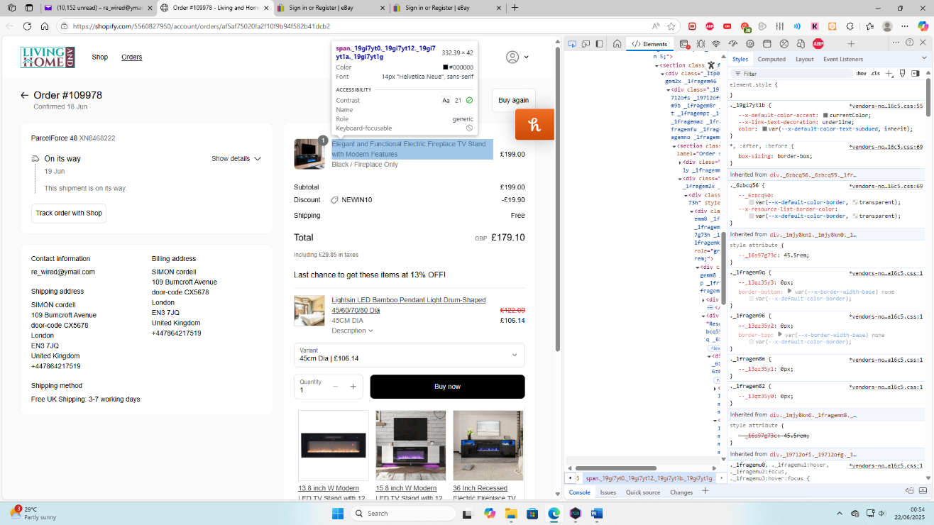

- Just below that, “Black / Fireplace Only” is rendered in grey (#707070)—visually matching the “unavailable “Fireplace TV Stand” option. As Exhibit “02” here:
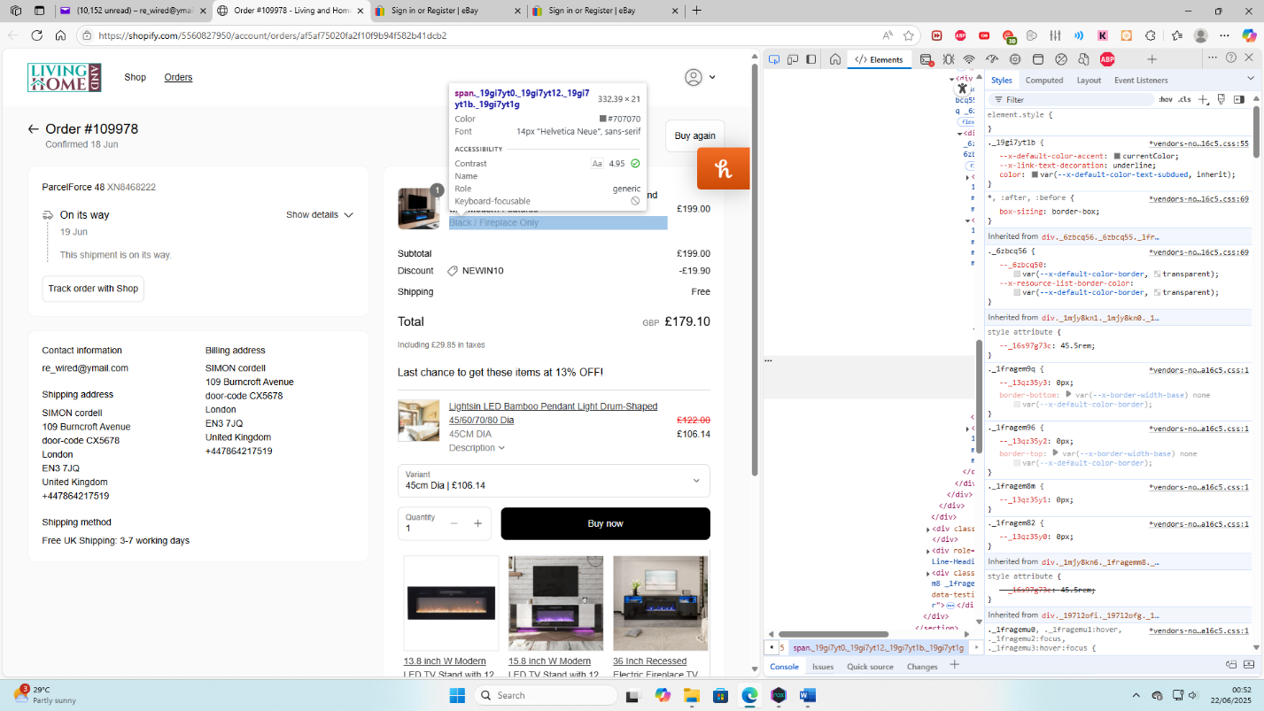

These grey tones are consistently used on your site to signal inaccessibility or exclusion. As such, any reasonable consumer, especially one unfamiliar with your interface—would perceive the grey “Fireplace Only” label as either an unselected option or an informational note about stock status.
Combined with the “Product Imagery,” which shows the TV stand and fireplace together, and the “Lack Of Any Option To Purchase The Stand Separately,” this led me to a “Transactional Decision I Would Not Have Made” had the listing been clearly presented.

This fulfills the definition of a “Misleading Omission,” and potentially a “Misleading Action,” under the Consumer Protection from Unfair Trading Regulations 2008 (Regulations 5 & 6).

Resolution Requested:
As a result, I respectfully request the following:
- A full refund, including return costs not to be borne by myself.
- Written acknowledgment that the product listing was misleading at the time of my order.

I am willing to resolve this directly with you, but I am fully prepared to submit my case to Trading Standards and my card issuer should resolution not be reached.
I trust this summary will allow you to reassess the facts impartially.

Kind regards, Mr. Simon Paul Cordell

